Jet Ranger Cockpit User Guide
Setting up, running, wiring, flashing and troubleshooting the Jet Ranger panel
Regenerated 18 October 2026
Contents
1 Overview 4
2 Windows and simulator 5
2.1 Starting up 5
2.2 Running the MSFS bridge 6
2.2.1 Aircraft with estimated dials 7
2.3 Running the FSUIPC bridge (Prepar3D and FSX) 8
2.4 Installing the DodoSim event file (FSUIPC) 8
2.4.1 Event naming 9
2.4.2 Event groups at a glance 9
3 Network 10
3.1 Packet format 11
3.2 What a board does 12
3.3 When the panel loses power 13
4 Arduino servo controller 14
4.1 Uploading the firmware 14
4.2 Servos 14
4.3 Other pins 15
4.4 What happens at power-up 15
4.5 Normal running 15
5 Stepper controller (13 Stepper board) 17
5.1 Behaviour 17
5.2 Testing a gauge on demand 18
5.3 Known issues 18
6 OLED dual stepper controller 19
6.1 OLED displays 20
6.2 Behaviour 20
6.3 Known issues 20
7 Radio controller (COM and NAV) 21
7.1 Boards 21
7.2 Inputs and outputs 21
7.3 Data from the PC (UDP 13136) 22
7.4 Commands to the PC (UDP 27001) 22
7.5 Display behaviour 23
7.6 Known issues 23
8 Joystick (HID) interface 24
8.1 How a switch becomes a joystick button 24
8.2 Switch mapping in use 25
8.3 Setting FSUIPC events from the joystick buttons 25
8.4 Known issues 26
9 COM ports and flashing 28
9.1 COM port to Arduino mapping 28
9.2 Flashing a board 29
10 PCBs and wiring 30
10.1 Connections on the servo carrier board 30
10.2 Wiring checklist 31
11 Calibration 32
11.1 Calibrating a servo 32
11.2 Calibrating a stepper gauge 32
12 Troubleshooting 33
12.1 Known issues in the code 34
12.2 Open questions 34
13 Reference: UDP tokens 35
13.1 Gauge tokens 35
13.2 Lamp tokens (servo board) 35
13.3 Status and control tokens 35

1 Overview
The Jet Ranger cockpit drives real gauge needles, warning lights, radio displays and switches from the simulator. A Windows PC exchanges UDP packets over Ethernet with Arduino Mega 2560 panel boards, and a small USB board presents the panel switches to Windows as joysticks.
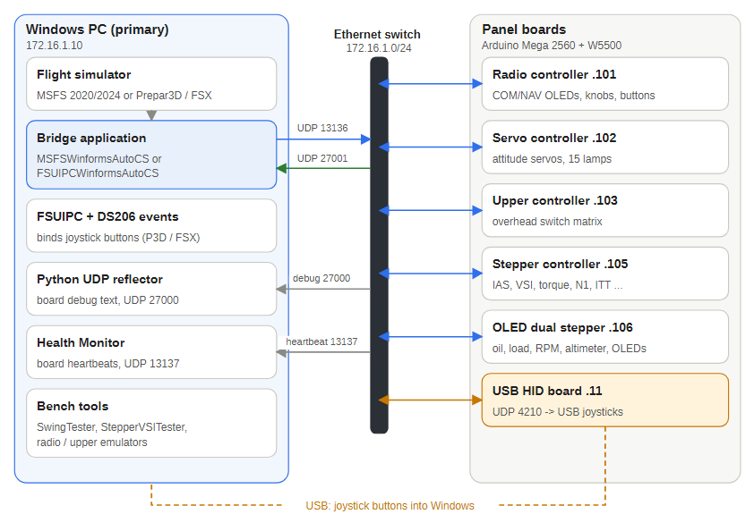
Figure 1 — The whole system
Data flows from the PC to the boards as short text packets. On the primary PC a Python listener shows the boards' debug messages and a separate Windows app, the Health Monitor, tracks their keep-alives. Cockpit switches reach the simulator separately, as joystick buttons (and, in Prepar3D and FSX, FSUIPC events).
Part | Hardware and software | Address | Section
Primary PC | Windows, MSFS 2020 or 2024, or Prepar3D / FSX with DodoSim 206 V2, one bridge program, debug listener, Health Monitor | 172.16.1.10 | Windows and simulator
Radio controller | Mega 2560 with the Radio Auto Pilot PCB and the COM and NAV panel | 172.16.1.101 | Radio controller
Servo board | Mega 2560 and Ethernet module on the Front Panel Servo PCB | 172.16.1.102 | Servo controller
Upper controller | Mega 2560 scanning the overhead switch matrix | 172.16.1.103 | Joystick (HID) interface
OLED controller | Mega 2560 driving altitude and barometer OLEDs | 172.16.1.104 | Reference
Stepper board | Mega 2560 on the Jet Ranger 13 Stepper PCB | 172.16.1.105 | Stepper controller
Dual stepper board | Mega 2560 on the OLED Dual Stepper PCB | 172.16.1.106 | Dual stepper controller
USB HID board | Leonardo-class board with native USB | 172.16.1.11 | Joystick (HID) interface

2 Windows and simulator
The Windows PC runs the simulator and a bridge program that turns simulator variables into UDP text packets for the Arduino boards. Switch inputs travel the other way as joystick buttons.
The bridge sends the Servo, Stepper and Dual Stepper boards each their own packet in real units (degrees, knots, feet per minute, psi, percent, degrees C), and the boards convert them with their own calibration. It sends about 10 packets per second to each board; the radio gets a packet whenever a frequency changes and at least every 5 seconds. The Dual Stepper's temperature OLED shows the outside air temperature from the simulator.
Component | Role | Notes
Simulator | Flies the DodoSim 206 or another Bell 206 Jet Ranger | MSFS 2020 or 2024, Prepar3D or FSX
FSUIPCWinformsAutoCS | Bridge for Prepar3D and FSX, reads FSUIPC offsets | Needs FSUIPC
MSFSWinformsAutoCS | Bridge for MSFS, reads SimConnect | Has estimates for the FlyInside B206 and CowaSim Jet Ranger
FSUIPC and DODSIM206V2.EVT | Exposes 234 DodoSim custom events so switches can be bound | Prepar3D and FSX only
Python debug listener | Shows debug messages from the boards | Listens on UDP 27000
Health Monitor | Tracks each board's keep-alive and flags a board that goes quiet | Listens on UDP 13137
Run only one bridge at a time: both listen for the radio board's commands on UDP 27001.

2.1 Starting up
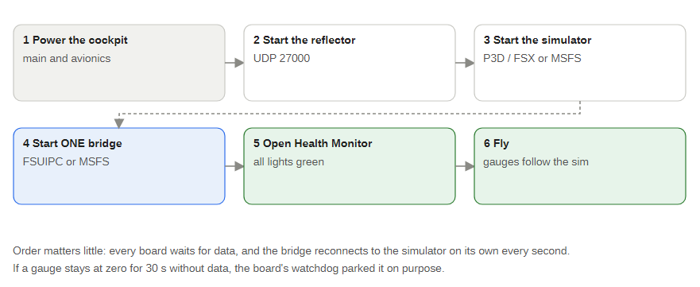
Figure 2 — Start-up order
- Power the cockpit (main and avionics).
- Start the debug listener (UDP 27000).
- Start the simulator.
- Start one bridge.
- Open the Health Monitor: every light should turn green within about 10 seconds.
- Fly. The gauges follow the simulator.
The order matters little: every board waits for data and the bridge reconnects to the simulator on its own every second. A gauge that stays at zero for 30 seconds without data was parked on purpose by the board's watchdog.
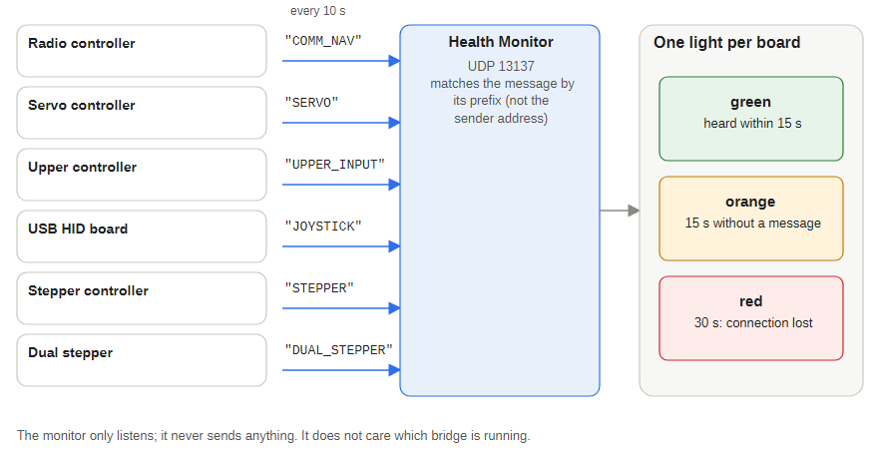
Figure 3 — Health Monitor

2.2 Running the MSFS bridge
- Build the project MSFSWinformsAutoCS (in the repository's C# Code folder) and run MSFSWinformsAutoCS.exe from its bin\Debug folder. Build output is not stored in git, so a fresh copy of the repository has to be built first.
- Close the FSUIPC bridge if it is running, then start MSFS and load a Jet Ranger. The status bar changes from Disconnected (red) to Connected to MSFS with the aircraft name (green) once data arrives.
- The window lists the values being sent and the warning lamps. The Avionics Master box follows the simulator and can also be used to switch it.
- If the status turns orange and says no data, the simulator is paused or loading and the bridge has stopped sending; the boards return their gauges to zero after 30 seconds and carry on when data returns.
- Five lamps are driven: engine out, rotor low, low fuel, generator fail (engine speed below 10 percent) and transmission oil pressure (below 40 psi, using the estimated pressure on the FlyInside and CowaSim). The other lamps need aircraft-specific variables. Some MSFS Jet Rangers do not report every value (for example transmission pressure and temperature), so those gauges may stay at zero. With the FlyInside B206 the estimated transmission pressure (35 psi) is below the 40 psi threshold, so that lamp stays on.
- The status bar shows the aircraft name the simulator reports and follows it when you load a different one.
- The electrical load follows the size of the total load whichever way the current flows, so with the engine stopped it still shows a load.
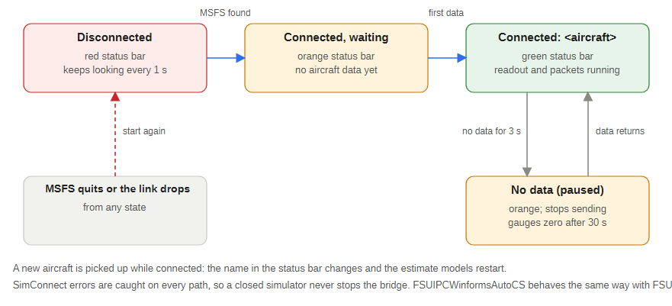
Figure 4 — Bridge status

2.2.1 Aircraft with estimated dials
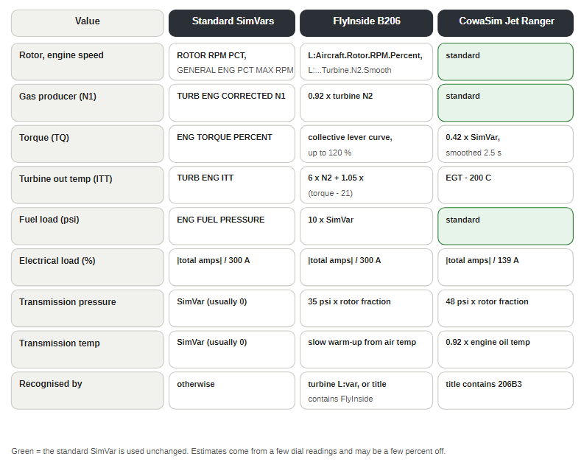
Figure 5 — Which values come from where
FlyInside B206. Its own gauges show values that are not in the standard simulator variables: rotor speed, engine speed, gas producer, torque, turbine out temperature, fuel pressure and transmission oil. The bridge reads the aircraft's own rotor and engine speed variables and estimates the rest from cockpit dial readings: torque follows the collective lever, turbine out temperature rises with torque, and the transmission oil pressure and temperature are modelled (the temperature warms up slowly from the outside air temperature and starts again from cold each time the bridge restarts). In this aircraft holding full collective for more than about 2 seconds over-torques the engine and breaks it. Its cockpit load dial stays at about 50 percent whatever the load.
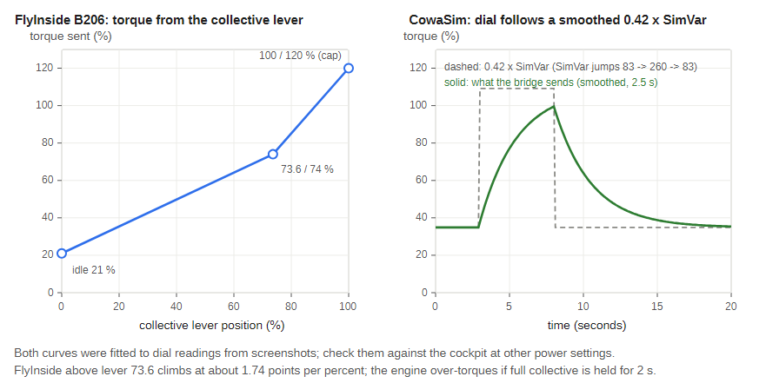
Figure 6 — Torque estimates
CowaSim Jet Ranger (shown as 206B3 with its registration). Most gauges match the standard variables. Its torque, turbine out temperature and electrical load dials do not, and it has no transmission oil values: the bridge smooths the torque, takes the turbine out temperature from the exhaust gas temperature, rescales the load and estimates the transmission oil from rotor speed and engine oil temperature.
These estimates were fitted to a few dial readings and may be a few percent off at other power settings, so compare the panel gauges with the cockpit dials. Other aircraft use the standard variables.

2.3 Running the FSUIPC bridge (Prepar3D and FSX)
Start FSUIPC with the simulator, then run FSUIPCWinformsAutoCS.exe. The status bar shows when it is connected to Prepar3D. The window lists the values being sent and the 21 annunciator bits. The bridge sends about 10 packets per second to each board and listens on UDP 27001 for the radio board's commands (frequency swaps, standby tuning, battery, alternator, avionics master).

2.4 Installing the DodoSim event file (FSUIPC)
Copy DODSIM206V2.EVT into the {P3D or FSX}/Modules folder, next to FSUIPC.ini. Add this to FSUIPC.ini if FSUIPC has not added it itself:
[EventFiles]
0=DodoSim206
Restart the simulator. The DS206.* events now appear in FSUIPC's button and key assignment lists. Bind each physical switch to its event. After an EVT update FSUIPC re-indexes events alphabetically, so check and re-map bindings.

2.4.1 Event naming
Suffix | Parameter | Behaviour | Example
_SET | Integer (usually 1 = on, 0 = off) | Sets a state directly; best for latching toggle switches | DS206.BATTERY_SWITCH_SET
_TOGGLE | None | Flips the state each press | DS206.FUEL_VALVE_SWITCH_TOGGLE
_TRIGGER | None (some take 1 to 10 as a multiplier) | Momentary; tick Control to repeat while held | DS206.STARTER_BUTTON_TRIGGER
none | None | One-shot action | DS206.CLOCK_MODE_BUTTON
For physical latching switches prefer the _SET events: send 1 on switch-on and 0 on switch-off so the simulator never drifts out of step with the panel.

2.4.2 Event groups at a glance
Group | Event numbers | Examples
Circuit breakers | 36 to 95, 107 to 110 | Hoist, SAS, fuel pumps, governor, ignition, starter
Lights and master switches | 96 to 101, 111 to 122, 209 to 212, 224 to 227 | Battery, generator, avionics, pitot heat, landing lights
Engine and flight controls | 1 to 2, 207 to 208, 213 to 223, 228 to 232 | Rotor brake, hydraulics, force trim, starter, governor beep
Instruments | 3 to 33 | Annunciator test, AI cage, radar altimeter, HSI and OBS knobs
Radios and audio | 129 to 192 | COM and NAV swap and tuning, ADF, DME, audio panel
Transponder | 193 to 206 | Mode knob, digit buttons, IDT, VFR
SAS modes | 123 to 128 | Master, HDG, NAV, SPD, ALT, VRT
Other | 102 to 106, 233 to 234 | Difficulty rotary, heat and vent, external power

3 Network
All devices sit on one wired 172.16.1.x subnet with fixed addresses; there is no DHCP on the boards.
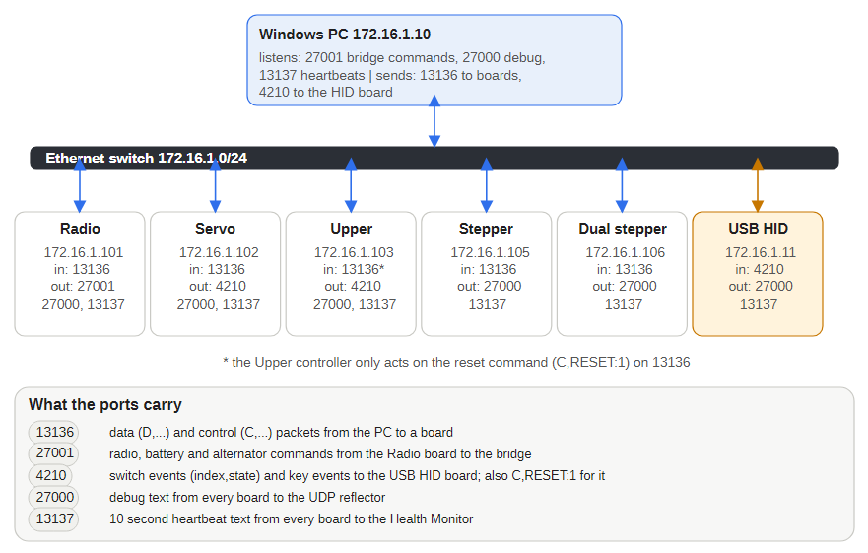
Figure 7 — Who talks to whom
Device | IP address | MAC | Keep-alive text
Primary PC (simulator, bridge, debug listener, Health Monitor) | 172.16.1.10
USB HID board | 172.16.1.11 | DE:AD:BE:EF:FE:ED | JOYSTICK
Radio controller | 172.16.1.101 | A8:61:0A:9E:83:01 | COMM_NAV
Servo board | 172.16.1.102 | A8:61:0A:9E:83:02 | SERVO
Upper controller | 172.16.1.103 | A8:61:0A:9E:83:03 | UPPER_INPUT
OLED controller | 172.16.1.104 | A8:61:0A:67:83:68 | none
Stepper board | 172.16.1.105 | A8:61:0A:67:83:69 | STEPPER
Dual stepper board | 172.16.1.106 | A8:61:0A:67:83:6A | DUAL_STEPPER
Every live board has its own IP and MAC address. The firmware sends its debug and keep-alive traffic to 172.16.1.10 (reflectorIP), so the primary PC must hold that address, or reflectorIP must be changed and the sketch uploaded again.
UDP port | Direction | Purpose
13136 | PC to boards | Gauge, lamp and radio data (D,) and control (C,) packets
27001 | Radio controller to PC bridge | Standby frequencies and commands such as COM1_RADIO_SWAP
4210 | Servo and Upper controllers to USB HID board | Switch changes (index,state) and keypad keys (KEY,key,state)
13137 | Boards to Health Monitor | Keep-alive text every 10 seconds
27000 | Boards to debug listener | Debug messages, each prefixed with the board name

3.1 Packet format
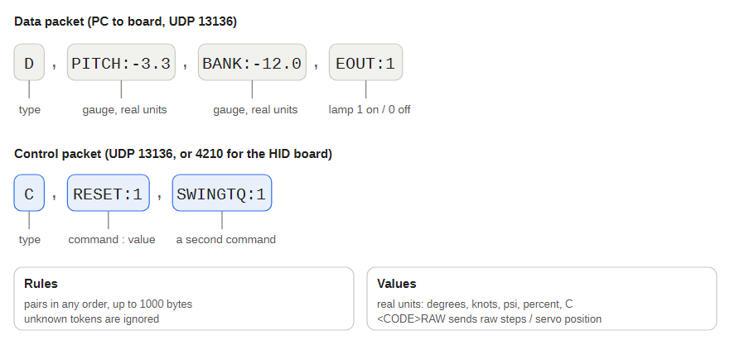
Figure 8 — Data and control packets
A packet can carry any number of pairs, in any order, up to 1000 bytes. Unknown tokens are ignored, so the PC can send only the values that changed. For example D,PITCH:5,BANK:-10,LOWF:0 sent to the servo board sets 5 degrees pitch, minus 10 degrees bank and turns off Low Fuel.
To test without the simulator, send a packet from a PC on the subnet, for example with PowerShell:
$u = New-Object System.Net.Sockets.UdpClient
$b = [Text.Encoding]::ASCII.GetBytes('D,PITCH:5,RLOW:1')
$u.Send($b, $b.Length, '172.16.1.102', 13136)

3.2 What a board does
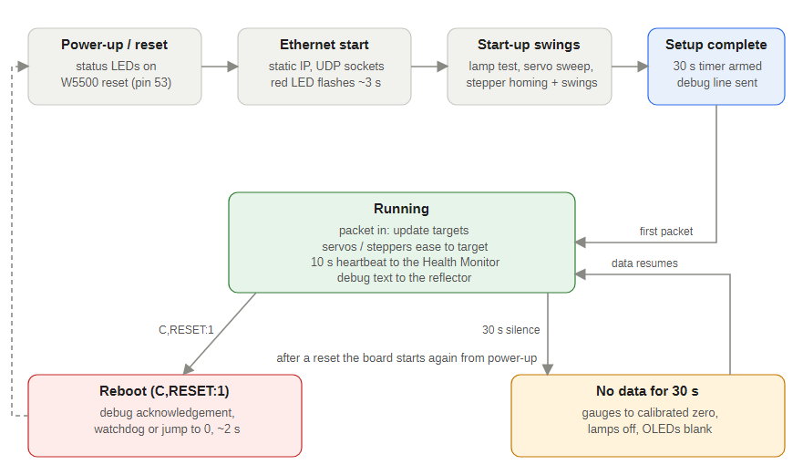
Figure 9 — Board life cycle
After start-up and its self-test a gauge board checks UDP 13136 every 5 ms and moves each needle smoothly towards its target. It sends its keep-alive every 10 seconds. If no packet arrives for 30 seconds every needle returns to zero (the Servo board also switches its lamps off, the Dual Stepper blanks its OLEDs and the Radio blanks its displays); the next packet brings everything back.
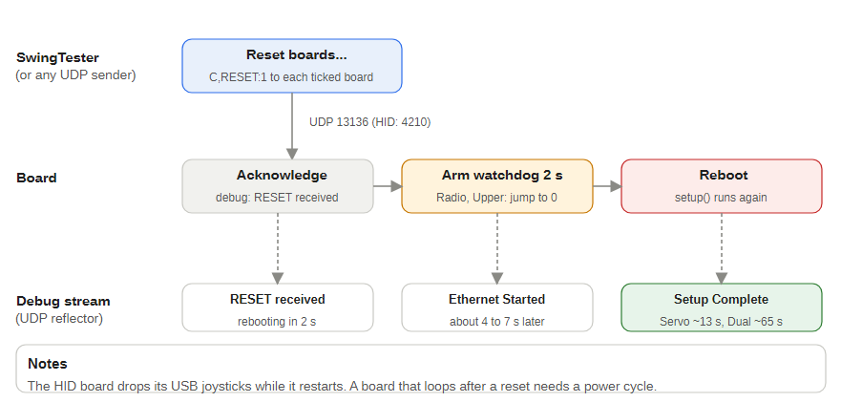
Figure 10 — Remote reset
The control packet C,RESET:1 reboots a board about 2 seconds later. The SwingTester's Reset boards... button sends it to the boards you tick.

3.3 When the panel loses power
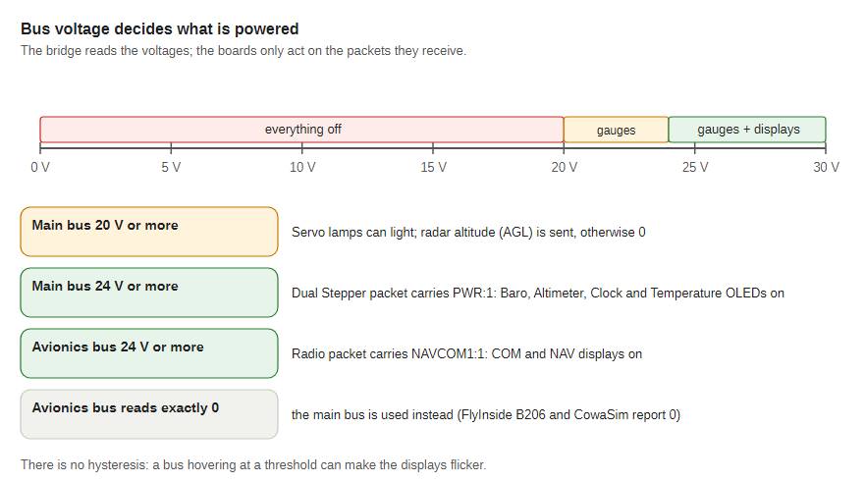
Figure 11 — Bus voltage rules
The bridge turns parts of the panel off when the simulated electrics drop: lamps and radar altitude below 20 V on the main bus, the Dual Stepper's four OLEDs below 24 V on the main bus, and the Radio's COM and NAV displays below 24 V on the avionics bus (the main bus is used if the aircraft reports the avionics bus as 0).

4 Arduino servo controller
The servo board is an Arduino Mega 2560 with an Ethernet module, on the Jet Ranger Front Panel Servo PCB at 172.16.1.102. It drives the attitude indicator's two servos, switches the 15 caution and warning lamps and reads three front-panel switches. It runs JET_RANGER_SERVO_CONTROLLER.ino. The other gauges that were once servo-driven now run on the two stepper boards.
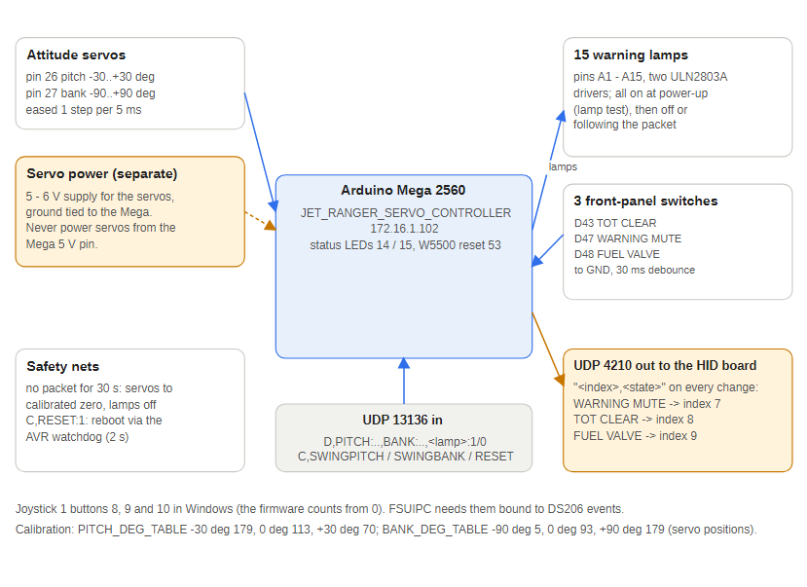
Figure 12 — Servo board

4.1 Uploading the firmware
- Open the sketch in the Arduino IDE and select Board: Arduino Mega or Mega 2560 (or use arduino-cli, see Flashing a board).
- Install the libraries it uses: Ethernet (with SPI), Servo, Ewma (jonnieZG) and DCS-BIOS.
- Upload, then watch the start-up self-test: both servos sweep and all 15 lamps light.

4.2 Servos
Instrument | Mega pin | UDP token | Range
Attitude bank (roll) | 27 | BANK | -90 to +90 degrees
Attitude pitch | 26 | PITCH | -30 to +30 degrees
Both tokens take attitude in degrees, with one decimal place allowed (D,PITCH:4.5,BANK:-12). The board turns degrees into a servo position with the tables in Calibration. BANKRAW and PITCHRAW take a raw servo position (0 to 180) and skip the tables. The PCB still has 16 servo headers from the earlier design; only pins 26 and 27 are used.

4.3 Other pins
Function | Pin | Behaviour
Green status LED | 14 | Flashes alternately with red every 200 ms while running
Red status LED | 15 | Fast flash during the 3 second Ethernet start-up, then alternates with green
Ethernet module reset | 53 | Pulsed low for 2 ms at power-up
Lamps | A1 to A15 | Digital outputs, HIGH = lit (see Reference)
TOT clear switch | 43 | Switch to GND, debounced 30 ms; each change goes to the USB HID board as Joystick 1 button 9 (index 8)
Warning mute switch | 47 | The same, Joystick 1 button 8 (index 7)
Fuel valve switch | 48 | The same, Joystick 1 button 10 (index 9)
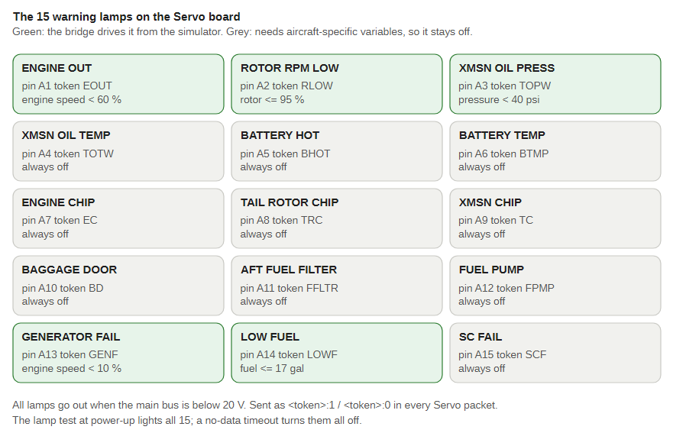
Figure 13 — The 15 lamps and their pins

4.4 What happens at power-up
- All 15 lamps switch on as a lamp test.
- The Ethernet module is reset and starts at 172.16.1.102; the red LED flashes for 3 seconds.
- Ethernet Started goes to the debug listener.
- Pitch, then bank, sweeps from minimum to maximum and back (about 2 seconds each) and parks at its calibrated level position.
- All lamps switch off.
- The starting state of the three switches is sent to the USB HID board, Setup Complete is logged and the 30 second watchdog starts.

4.5 Normal running
- Every 5 ms the board checks UDP 13136 and stores each value as a new target; each servo steps one position towards its target, so the attitude indicator moves smoothly.
- A servo that has not moved for 1 second is detached to stop buzz; the next movement re-attaches it.
- Lamps change as soon as a 0 or 1 arrives.
- C,SWINGPITCH:1 or C,SWINGBANK:1 re-runs one sweep on demand (the board pauses for about 2 seconds).

5 Stepper controller (13 Stepper board)
A second Arduino Mega 2560, on the Jet Ranger 13 Stepper PCB at 172.16.1.105, drives X27-style stepper gauges directly from its pins. Unlike the servo board it takes real units and converts them to needle steps with calibration tables in JET_RANGER_STEPPER_CONTROLLER.ino.
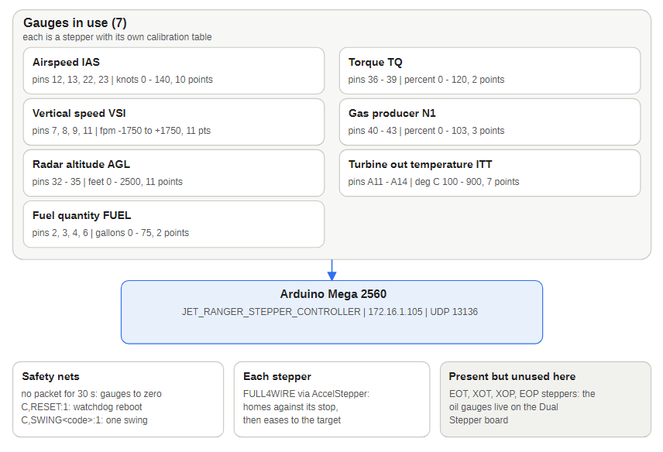
Figure 14 — Stepper board
Gauge | Token | Mega pins | Units | Calibration
Airspeed | IAS | 12, 13, 22, 23 | knots 0 to 140 | 10-point table
Vertical speed | VSI | 7, 8, 9, 11 | ft/min, plus and minus 1750 | 11-point table
Radar altitude | AGL | 32 to 35 | feet 0 to 2500 | 11-point table
Torque | TQ | 36 to 39 | percent 0 to 120 | 2-point table
Gas producer | N1 | 40 to 43 | percent 0 to 103 | 3-point table
Turbine out temperature | ITT | A11 to A14 | degrees C 100 to 900 | 7-point table
Fuel quantity | FUEL | 2, 3, 4, 6 | US gallons 0 to 75 | 2-point table
Every token has a raw twin with RAW on the end (for example IASRAW:300). It moves the needle by raw steps and skips the table, which is how new calibration points are measured on the bench. The board also has four oil and transmission steppers with placeholder scales; those gauges are driven from the Dual Stepper, so wire each physical gauge to one board only. Pins 24 to 31 are free.

5.1 Behaviour
- Power-up: status LEDs flash, Ethernet starts, backlighting ramps up, then each gauge does a self-test sweep in turn: fuel, torque, turbine out, gas producer, VSI, airspeed, radar altitude. Each sweep has its own on/off switch (SwingFA, SwingTQ and so on) near the top of the sketch.
- Running: every 5 ms the board checks UDP 13136 and moves each needle towards its target with smooth acceleration.
- No-data watchdog: after 30 seconds without a packet every needle returns to its zero.
- Zero trims: each gauge has a ...ZeroOffset value to nudge its true zero without touching the table.
- Keep-alive: STEPPER to the Health Monitor every 10 seconds; debug text goes to UDP 27000.

5.2 Testing a gauge on demand
Send a control packet to re-run one gauge's sweep without rebooting, for example C,SWINGTQ:1.
Command | Gauge
SWINGFUEL | Fuel quantity
SWINGTQ | Torque
SWINGITT | Turbine out temperature
SWINGN1 | Gas producer
SWINGVSI | Vertical speed
SWINGIAS | Airspeed
SWINGAGL | Radar altitude
The StepperVSITester app can send every token and raw token to this board without the simulator. The SwingTester app sends these commands, and the Dual Stepper and servo sweeps, one at a time or all in a fixed order:
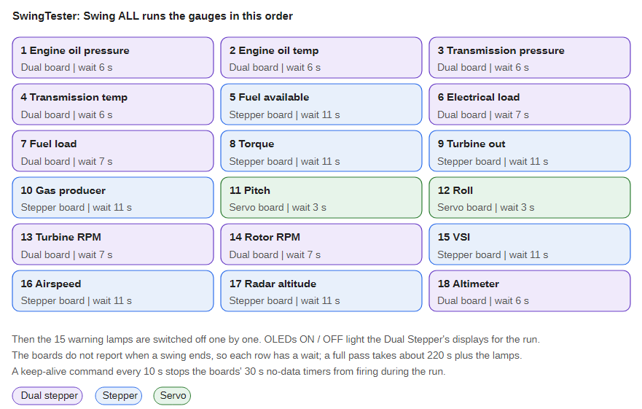
Figure 15 — Swing ALL sequence
It lights the OLEDs and the lamps during the run and sends a keep-alive so the boards' 30 second watchdogs do not fire. Reset boards... reboots the boards you tick (Radio, Servo, Upper, Stepper, Dual Stepper, USB HID) by sending each one C,RESET:1; each restarts about 2 seconds later and repeats its power-up test.

5.3 Known issues
- The backlight PWM was once on pin 8, which the PCB routes to VSI coil B. It is now pin 5, matching the PCB's BACKLIGHT_PWM net, in both stepper sketches.
- Pin 32 is also claimed by an unused roll stepper in the code.
- The oil, transmission and placeholder gauges use a shared linear scale, not bench-measured tables.

6 OLED dual stepper controller
A third Mega, on the Jet Ranger OLED Dual Stepper PCB at 172.16.1.106, drives stepper gauges plus four small OLED displays. It runs JET_RANGER_OLED_DUAL_STEPPER_CONTROLLER.ino and, like the 13 Stepper board, takes real units.
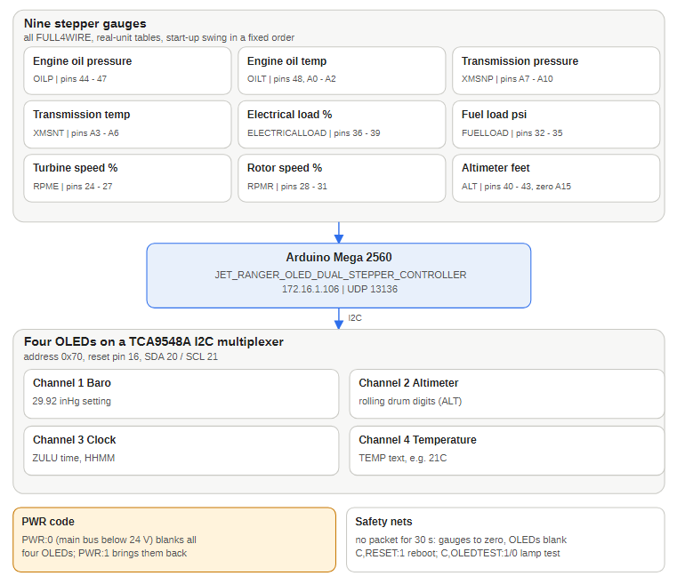
Figure 16 — Dual stepper board
Gauge | Token | Mega pins | Units | Calibration
Engine speed (N2) | RPME | 24 to 27 | percent, one decimal | 4-point table
Rotor speed | RPMR | 28 to 31 | percent, one decimal | 4-point table
Altimeter | ALT | 40 to 43, zero sensor A15 | feet | 720 steps per 1000 ft
Fuel load | FUELLOAD | 32 to 35 | psi | 2-point table (0 to 30 psi)
Electrical load | ELECTRICALLOAD | 36 to 39 | percent | 2-point table
Engine oil temperature | OILT | 48, A0 to A2 | degrees C | 4-point table
Engine oil pressure | OILP | 44 to 47 | psi | 4-point table
Transmission oil temperature | XMSNT | A3 to A6 | degrees C | 4-point table
Transmission oil pressure | XMSNP | A7 to A10 | psi | 5-point table
Turbine out temperature (ITT) and fuel quantity (FUEL) are also accepted, as on the 13 Stepper board. Wire each physical gauge to one board only; the matching channel on the other board then simply has nothing connected. Each token also has a RAW twin for bench work. IAS is not handled here; the FSUIPC and MSFS bridges send airspeed to the 13 Stepper board with one decimal place so the needle moves smoothly.

6.1 OLED displays
The four 128 by 32 SSD1306 OLEDs share the Mega's I2C pins (20 SDA, 21 SCL) through a TCA9548A multiplexer at address 0x70. The firmware pulses the mux reset on pin 16 at start-up.
Display | Mux channel | UDP token | Shows
Barometric setting | 1 | none yet | 2992 at boot; not updated
Altimeter digits | 2 | ALT | Rolling-drum altitude, raw MSL (barometric correction off)
Clock | 3 | ZULU | Zulu time from HHMM, for example ZULU:1430
Temperature | 4 | TEMP | Text as sent, for example TEMP:25C
Send C,OLEDTEST:1 to light all four displays solid and C,OLEDTEST:0 to restore them. When the main bus is below 24 V the bridge sends PWR:0 and all four displays go blank; PWR:1 turns them back on and they repaint within about a second. The altimeter needle keeps following altitude. The lamp test still lights all four displays whatever PWR says.

6.2 Behaviour
- Power-up: OLEDs start first, then each gauge sweeps in turn: engine oil pressure, engine oil temperature, transmission pressure, transmission temperature, electrical load, fuel load, engine RPM, rotor RPM, altimeter. The altimeter seeks its zero sensor before sweeping. Start-up takes about 65 seconds.
- No-data watchdog: after 30 seconds without a packet the needles return to zero and all OLEDs blank.
- On-demand sweeps: C,SWINGOILP:1, SWINGOILT, SWINGXMSNP, SWINGXMSNT, SWINGELECTRICALLOAD, SWINGFUELLOAD, SWINGRPME, SWINGRPMR, SWINGALT. Each blocks the board for 5 to 7 seconds.
- Keep-alive: DUAL_STEPPER to the Health Monitor every 10 seconds, so it shows separately from the 13 Stepper board.

6.3 Known issues
- RAM use is 75 percent or more; avoid adding more OLEDs or string-heavy code.
- The latest bench I2C scan found OLEDs on mux channels 1 to 4; check by eye that each shows its text.
- Engine and rotor RPM tables assume 0 percent is 0 steps; RSoffset is not yet measured.
- The altimeter zero seek travels up to 10,080 steps (about 14 turns) before giving up.

7 Radio controller (COM and NAV)
The radio panel is another Mega at 172.16.1.101, running JET_RANGER_RADIO_CONTROLLER.ino. It shows the COM and NAV frequencies on two OLEDs, reads eight tuning knobs and a 4 by 4 button matrix, and sends knob and button actions back to the PC.
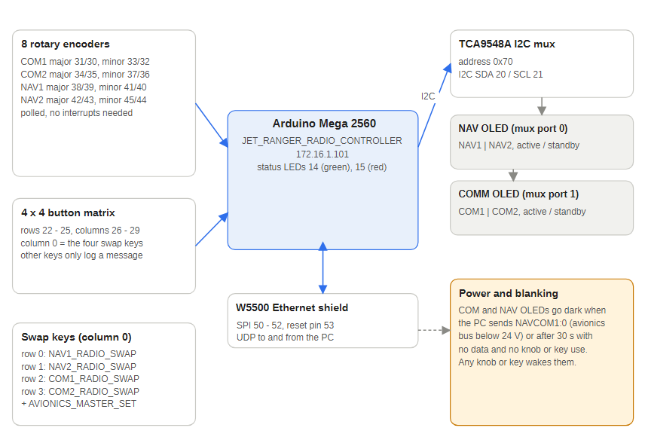
Figure 17 — Radio panel

7.1 Boards
PCB | Role | Main parts
Jet Ranger Radio Auto Pilot | Radio controller board | Mega 2560 shield, Ethernet module, TCA9548A I2C mux
Jet Ranger COM and NAV | Front panel board behind the radio faceplate | 8 rotary encoders, push buttons, four frequency-swap switches

7.2 Inputs and outputs
Function | Mega pins | Notes
COM1 major and minor knob | 31, 30 and 33, 32 | Encoder A, B
COM2 major and minor knob | 34, 35 and 37, 36 | Encoder A, B
NAV1 major and minor knob | 38, 39 and 41, 40 | Encoder A, B
NAV2 major and minor knob | 42, 43 and 45, 44 | Encoder A, B
Button matrix | rows 22 to 25, columns 26 to 29 | 4 by 4
OLEDs | I2C through the TCA9548A (0x70) | Port 0 = NAV OLED, port 1 = COM OLED, both at 0x3C
Status LEDs | 14 green, 15 red | Red flashes while Ethernet starts
Ethernet module | SPI 50 to 52, reset 53

7.3 Data from the PC (UDP 13136)
Token | Meaning | Example
C1A, C1S | COM1 active and standby frequency | C1A:119.500
C2A, C2S | COM2 active and standby frequency | C2S:121.900
NAVCOM1 | Radio power (0 = off) | NAVCOM1:1
MAINBUS | Main bus voltage
C,B:n | Display brightness (control packet) | C,B:5

7.4 Commands to the PC (UDP 27001)
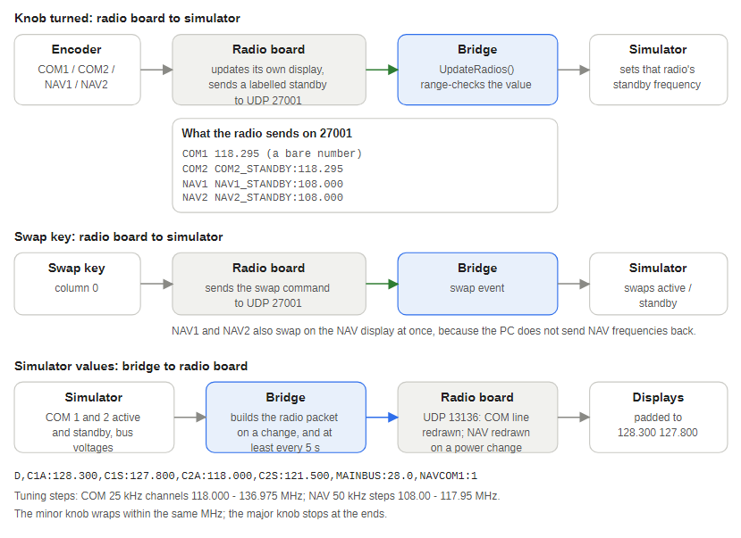
Figure 18 — Where each input goes
Turning a knob changes the standby frequency on the OLED and sends the new value to the PC. The four swap switches share matrix column 0:
Switch (row, column 0) | Command sent
Row 0: NAV1 FREQ | NAV1_RADIO_SWAP
Row 1: NAV2 FREQ | NAV2_RADIO_SWAP
Row 2: COMM1 | COM1_RADIO_SWAP
Row 3: COMM2 | COM2_RADIO_SWAP, then AVIONICS_MASTER_SET
The bridge listens on 27001 and turns these into simulator events. NAV1 and NAV2 also swap their active and standby frequencies on the NAV OLED straight away, because the PC does not send NAV frequencies back; the COM swaps change the display only when the simulator returns the swapped frequencies. Other buttons are only logged to the debug listener.
Each knob sends its standby frequency with the radio's name: COM1 as the bare number (for example 118.295), the others as COM2_STANDBY:118.295, NAV1_STANDBY:108.000 or NAV2_STANDBY:108.000. Nothing is sent during the first 1.5 seconds after power-up, so the knobs' start positions do not change the simulator. Each OLED line always shows two frequencies in a fixed 16-column layout.
Tuning steps follow the standard channel spacing. The COM knobs run 118.000 to 136.975 MHz in 25 kHz channels (the major knob picks 118 to 136, the minor knob 000, 025, 050 and 075). The NAV knobs run 108.00 to 117.95 MHz in 50 kHz steps (major 108 to 117, minor 000, 050, 100 and so on). Each minor knob wraps round at the ends. 8.33 kHz channels are not offered. FSUIPC holds COM frequencies to 10 kHz, so in that simulator a channel such as 118.025 may appear as 118.02 or 118.03.

7.5 Display behaviour
- If no data arrives from the PC for 30 seconds and no knob or button is used, both OLEDs blank (as if the radio had no power). Turning a knob, pressing a button or new data switches them back on.
- When the avionics bus is below 24 V the bridge tells the radio the power is off (NAVCOM1:0) and the COM and NAV displays go blank together; they light together again when the bus rises.
- At power-up the matrix is ignored for the first 1.5 seconds so a floating input cannot send false button presses.
- The radio sends COMM_NAV to the Health Monitor every 10 seconds.

7.6 Known issues
- Only COM1 and COM2 frequencies arrive from the PC; there are no NAV frequency tokens yet, although the NAV knobs are read.
- If every button in the matrix's first column stops working, send C,MATRIX:1 to port 13136: the radio prints the raw H or L state of each column to the debug listener. A column that reads L with nothing pressed is a hardware fault on that Mega pin or board (a faulty or badly seated Mega did exactly this on the bench).

8 Joystick (HID) interface
Overhead and console switches reach the simulator as ordinary USB joystick buttons. The upper controller scans the switches and sends each change over UDP to a small USB board, UDP_TO_HID, which Windows sees as four joysticks and a keyboard. The joysticks have buttons only: no axes and no hat switches. Bind them like any other controller, in FSUIPC for Prepar3D and FSX or in the MSFS controls menu.
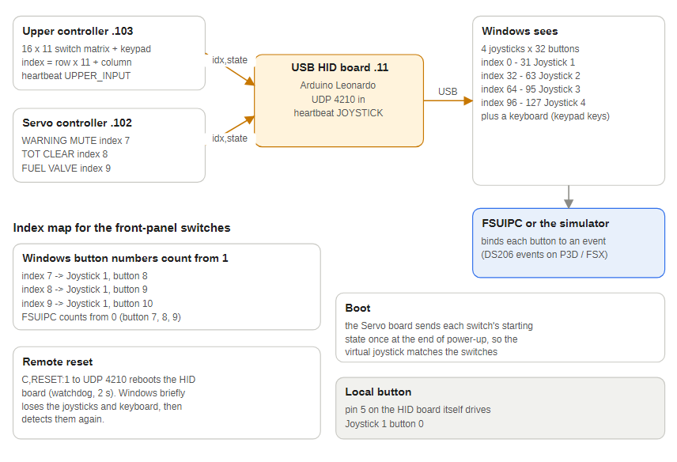
Figure 19 — From switch to joystick button
Board | Sketch | Address | Role
Upper controller (Mega 2560) | JET_RANGER_UPPER_CONTROLLER.ino | 172.16.1.103 | Scans a 16 by 11 switch matrix (rows on pins 22 to 37, columns on 38 to 48) and a 4 by 3 keypad (A9 to A15)
USB HID board (Leonardo class) | UDP_TO_HID.ino | 172.16.1.11 | Listens on UDP 4210 and presents 4 joysticks of 32 buttons plus a keyboard
Servo board (Mega 2560) | JET_RANGER_SERVO_CONTROLLER.ino | 172.16.1.102 | Also sends three front-panel switches (warning mute, TOT clear, fuel valve) as index 7, 8 and 9

8.1 How a switch becomes a joystick button
- The upper controller numbers each matrix position as index = row x 11 + column (0 to 175).
- When a switch changes it sends index,state to 172.16.1.11:4210, with state 1 = switch on and 0 = off.
- The HID board picks joystick = index div 32 and button = index mod 32, then holds that button down while the switch is on.
- Keypad keys are sent as KEY,<key>,<state> and typed as keyboard keys 0 to 9, * and #.
- The servo board sends the same format for its three switches: index 7 (warning mute, pin 47), 8 (TOT clear, pin 43) and 9 (fuel valve, pin 48), with 1 = closed.
Index range | Windows device
0 to 31 | Joystick 1
32 to 63 | Joystick 2
64 to 95 | Joystick 3
96 to 127 | Joystick 4
128 to 175 | Not sent to Windows (out of range)

8.2 Switch mapping in use
From UpperSwitchMapping.ods. Button numbers are as Windows and the simulators show them (1 to 32); the firmware counts from 0. A latching switch holds its button down while on, so bind both press and release: in FSUIPC use the _SET event with parameter 1 on press and 0 on release.
Index | Source | Switch | Joystick, button | Suggested DodoSim event
0 to 4 | Upper 0, 0-4 | Heater rotary HTR 0 to 4 | J1, 1 to 5
5 | Upper 0, 5 | Air vent | J1, 6 | HEAT_VENT_SWITCH_SET
6 | Upper 0, 6 | Air heat | J1, 7 | HEAT_VENT_SWITCH_SET
7 | Servo D47 | Warning mute | J1, 8 | DS206.WARNING_MUTE_BUTTON_SET
8 | Servo D43 | TOT clear (TOT light test) | J1, 9 | DS206.TOT_TEST_BUTTON_SET
9 | Servo D48 | Fuel valve | J1, 10 | DS206.FUEL_VALVE_SWITCH_SET
11 | Upper 1, 0 | Forward fuel boost breaker | J1, 12 | FORE_FUEL_PUMP_CB_SET
12 | Upper 1, 1 | Aft fuel boost breaker | J1, 13 | AFT_FUEL_PUMP_CB_SET
13 | Upper 1, 2 | Generator field breaker | J1, 14 | GENERATOR_FIELD_CB_SET
14 | Upper 1, 3 | Generator breaker | J1, 15 | GENERATOR_RESET_CB_SET
15 | Upper 1, 4 | Directional gyro / attitude indicator | J1, 16 | DIR_GYRO_SWITCH_SET
16 | Upper 1, 5 | Battery | J1, 17 | BATTERY_SWITCH_SET
17 | Upper 1, 6 | Generator (on / start) | J1, 18 | GENERATOR_SWITCH_SET
22 | Upper 2, 0 | Landing light | J1, 23 | LANDING_LIGHT_SWITCH_SET
23 | Upper 2, 1 | Instrument lights | J1, 24 | PANEL_LIGHTS_SWITCH_SET
24 | Upper 2, 2 | Caution light breaker | J1, 25 | CAUTION_LT_CB_SET
25 | Upper 2, 3 | Anti-collision light | J1, 26 | COLLISION_LIGHTS_SET
26 | Upper 2, 4 | Position lights | J1, 27 | POSITION_LIGHTS_SET
27 | Upper 2, 5 | Pitot heat | J1, 28 | PITOT_HEAT_SWITCH_SET
28 | Upper 2, 6 | Avionics | J1, 29 | AVIONICS_SWITCH_SET
39 | Upper 3, 6 | Strobe light | J2, 8 | none yet
The suggested events are the closest match in DODSIM206V2.EVT; the bindings actually saved in FSUIPC or MSFS are not in the repository. All other matrix positions are wired but unassigned.

8.3 Setting FSUIPC events from the joystick buttons
A joystick button does nothing in the simulator until it is bound to an event in FSUIPC. The Warning Mute and Fuel Valve switches on the servo board must be set this way before they work; the TOT clear switch beside them is bound the same way. This applies to Prepar3D and FSX with FSUIPC and DODSIM206V2.EVT installed. In MSFS, bind the buttons in the controls menu instead; the DS206 events are not available there.
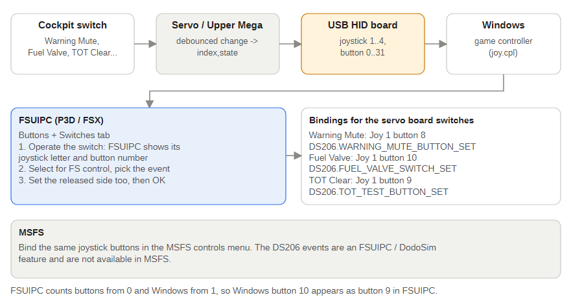
Figure 20 — Binding a switch
- Start the simulator with the USB HID board connected. Windows should list the four joysticks (Game Controllers, joy.cpl); pressing a switch lights the matching button there.
- In the simulator open FSUIPC from the Add-ons menu and choose the Buttons + Switches tab.
- Operate the switch you want to bind (for example flip the Fuel Valve switch). FSUIPC shows the joystick letter and button number it saw. FSUIPC counts buttons from 0 and Windows from 1, so Windows button 10 shows as button 9 in FSUIPC.
- Under the pressed (or closed) side, tick Select for FS control, choose the event from the list and type the parameter in the box beside it. The DS206 events are listed alphabetically.
- A switch that stays on needs the released side set as well: tick Select for FS control there, choose the same event and enter the opposite parameter, so the cockpit follows the switch in both directions.
- Click OK, flip the switch and check the result in the cockpit. After an event file update FSUIPC re-indexes the events alphabetically, so check these bindings again.
- Warning Mute: Joystick 1 button 8 (FSUIPC button 7). Event DS206.WARNING_MUTE_BUTTON_SET, parameter 1 when pressed and 0 when released. Alternatively bind DS206.WARNING_MUTE_BUTTON_TRIGGER (no parameter) to the pressed side only.
- Fuel Valve: Joystick 1 button 10 (FSUIPC button 9). Event DS206.FUEL_VALVE_SWITCH_SET, parameter 1 when closed and 0 when released. The valve in the simulator follows the switch; if it ends up the wrong way round, swap the two parameters.
- TOT clear (TOT light test): Joystick 1 button 9 (FSUIPC button 8). Event DS206.TOT_TEST_BUTTON_SET, parameter 1 when pressed and 0 when released.
If FSUIPC does not see a switch, check that Windows shows the button moving in joy.cpl first. If it does not, the problem is on the board side: the servo board's debug messages report each change and the HID board logs the button it sets.

8.4 Known issues
- The HID board's own test button on pin 5 also drives Joystick 1 button 1, the same button as HTR 0.
- CreateDcsBiosMessage() is still a stub, so these switches do nothing in DCS; only the joystick path works.
- The HID board reboots when it receives C,RESET:1 (or RESET) on UDP 4210. Its USB connection drops while it restarts, so Windows briefly loses the four joysticks and the keyboard; re-check any game that has them open.
- The servo board's three switches use indexes 7, 8 and 9, which Windows shows as Joystick 1 buttons 8, 9 and 10. If they were meant to be Windows buttons 7, 8 and 9, button 7 is already the Air heat switch (index 6), so the indexes would have to move.

9 COM ports and flashing
Each Arduino is programmed over its own USB cable from the primary PC. The cockpit itself runs over Ethernet, so USB is only needed to upload a sketch.

9.1 COM port to Arduino mapping
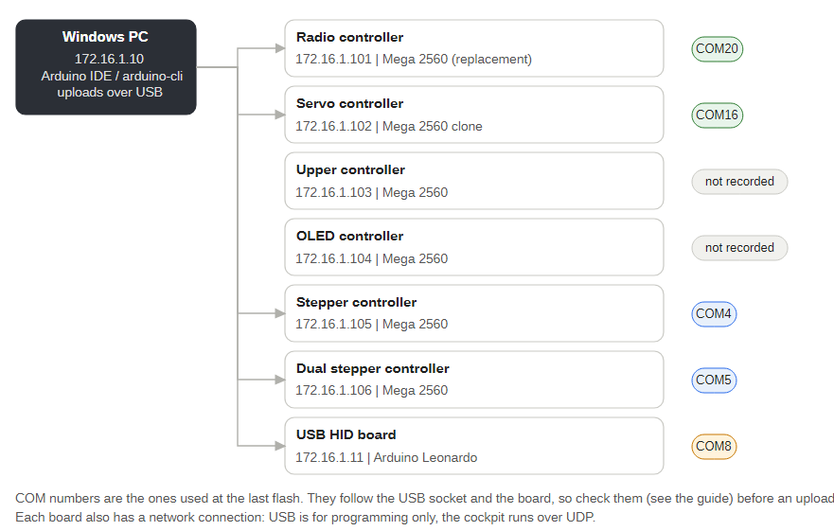
Figure 21 — Which board is on which COM port
Board | Address | Hardware | COM port | Sketch
Radio controller | 172.16.1.101 | Arduino Mega 2560 (replacement board) | COM20 | JET_RANGER_RADIO_CONTROLLER
Servo controller | 172.16.1.102 | Mega 2560 clone | COM16 | JET_RANGER_SERVO_CONTROLLER
Upper controller | 172.16.1.103 | Mega 2560 | not recorded | JET_RANGER_UPPER_CONTROLLER
OLED controller | 172.16.1.104 | Mega 2560 | not recorded | JET_RANGER_OLED_CONTROLLER
Stepper controller | 172.16.1.105 | Mega 2560 | COM4 | JET_RANGER_STEPPER_CONTROLLER
Dual stepper controller | 172.16.1.106 | Mega 2560 | COM5 | JET_RANGER_OLED_DUAL_STEPPER_CONTROLLER
USB HID board | 172.16.1.11 | Arduino Leonardo | COM8 | UDP_TO_HID
These are the ports used the last time each board was flashed. A COM number belongs to a USB socket and a board together, so it can change:
- The Servo controller is a clone Mega that reports no USB serial number, so Windows ties its COM number to the USB socket it is plugged into. Plug it into a different socket and it appears as a new port.
- Replacing a Mega (the Radio controller was replaced once) gives a new port number.
- The Upper and OLED controllers were not connected when the ports were recorded.
Always check the port before an upload: open Device Manager, Ports (COM and LPT), or run arduino-cli board list. If you are not sure which board is which, unplug one USB cable and see which port disappears. Add the confirmed port to the table above (and to the sketch header comment) once you have uploaded to a board.

9.2 Flashing a board
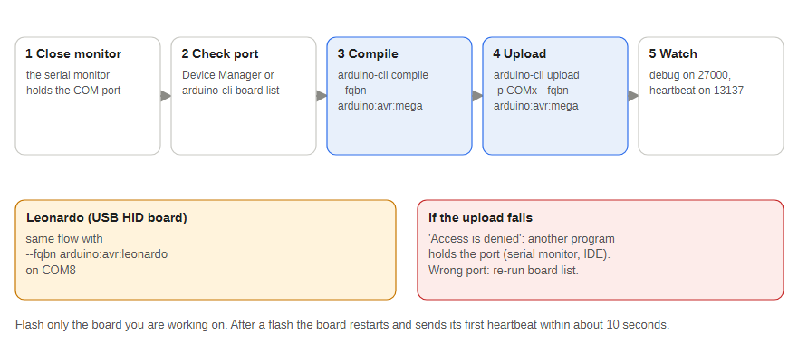
Figure 22 — Flashing a board
- Close the Arduino IDE serial monitor. It holds the port, and an upload then fails with Access is denied.
- Check the COM port (above).
- Compile the sketch.
- Upload to that port.
- Watch the debug listener (UDP 27000) and the Health Monitor: the board prints Ethernet Started and Setup Complete and its light goes green within about 10 seconds.
arduino-cli compile --fqbn arduino:avr:mega "Jet Ranger Arduino Sketches\JET_RANGER_STEPPER_CONTROLLER"
arduino-cli upload -p COM4 --fqbn arduino:avr:mega "Jet Ranger Arduino Sketches\JET_RANGER_STEPPER_CONTROLLER"
For the Leonardo (USB HID board) use --fqbn arduino:avr:leonardo and its port, COM8. Flash only the board you are working on. If a board ever reboot-loops after a reset packet, power-cycle it and flash it again.

10 PCBs and wiring
The Mega sits on a carrier PCB that breaks its pins out to servo headers, lamp outputs, gauge sockets and the Ethernet module. KiCad projects for every board are in Jet Ranger/PCBs in the repository, with Gerbers in each MANUFACTURING folder.
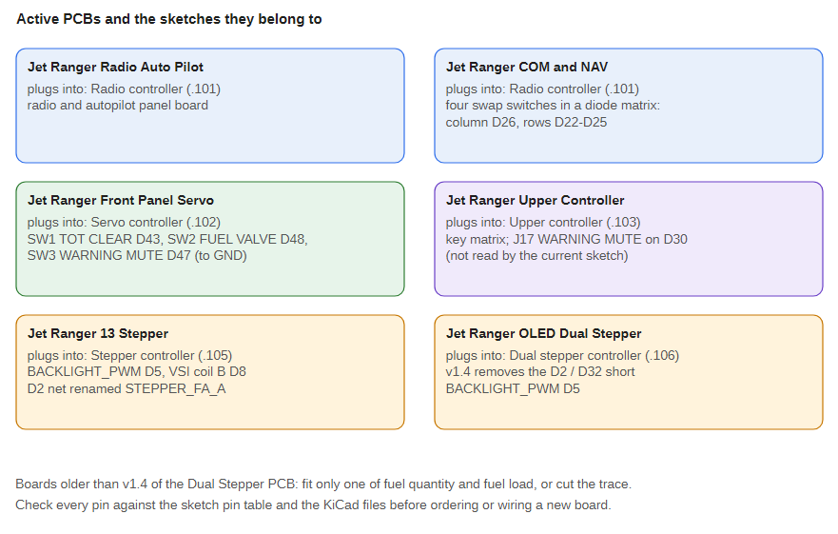
Figure 23 — Active PCBs
PCB | Used by | Main parts
Jet Ranger Front Panel Servo | Servo board | Mega shield, ULN2803A lamp drivers, servo headers, lamp outputs
Jet Ranger 13 Stepper | Stepper board | Mega shield, USR-ES1 Ethernet, 14 six-pin gauge sockets, 12 V lamp supply with polyfuses
Jet Ranger OLED Dual Stepper | Dual stepper board | Mega shield, USR-ES1, six-pin gauge sockets, TCA9548A sockets for the OLEDs
Jet Ranger X27 Small Stepper | Each stepper gauge | One X27 or VID29 stepper, backlight LED, six-pin connector to the controller
Jet Ranger Radio Auto Pilot | Radio controller | Radio controller board
Jet Ranger COM and NAV | Radio panel | 8 rotary encoders, push buttons, four frequency-swap switches
Jet Ranger Upper Controller | Upper controller | Mega shield for the switch matrix
The X27 steppers run straight from the Mega's pins, so the stepper boards need no driver chips; the 12 V input feeds lamps and backlights.
Version 1.4 of the OLED Dual Stepper PCB (12 October 2026) separates Mega pins 2 and 32. Earlier versions joined them in copper because of a copy-and-paste net name, so the fuel quantity and fuel load gauges shared coil A. On a board older than 1.4 fit only one of those two gauges or cut the trace between the pins.

10.1 Connections on the servo carrier board
Connector | Count | Pins | Wiring
Servo headers | 16 on the PCB, 2 used | 26 (pitch), 27 (bank) | Signal, +V, GND; +V from the servo rail
Lamp outputs | 15 | A1 to A15 | Pin HIGH = lamp on; through a driver for lamps above 20 mA
Spare outputs | 3 | not assigned | Reserved for future lights
Ethernet module | 1 | SPI 50 to 52, chip select, reset 53 | Reset is pulsed by the firmware at start-up
Status LEDs | 2 | 14 green, 15 red | With series resistors to GND
Servo power input | 1 |  | 5 to 6 V; ground joined to Mega GND
Front-panel switch inputs | 3 | D43, D47, D48 | Each to GND through a switch (SW1 TOT clear, SW3 warning mute, SW2 fuel valve); internal pull-up, debounced in firmware
The rule that matters most: never power servos from the Mega's 5 V pin. Servos draw current spikes when they move, which can reset the Mega and drop the Ethernet link.

10.2 Wiring checklist
- Servo rail fed from its own 5 to 6 V supply, not the Mega.
- Supply ground joined to Mega GND (signals need a shared reference).
- Each servo plugged in signal-side matching the header silkscreen.
- Lamps checked during the power-up lamp test.
- Ethernet cable to the same switch as the primary PC.
- Board serial number noted in the sketch header.

11 Calibration
The servo board turns attitude degrees into a servo position (0 to 180) with two small tables in the sketch. The stepper boards do the same for steps. Between table points the boards interpolate in a straight line; beyond the ends they hold the end value.
Instrument | Attitude | Servo position
Pitch (PITCH_DEG_TABLE) | -30 degrees | 179
Pitch | 0 (level) | 113
Pitch | +30 degrees | 70
Bank (BANK_DEG_TABLE) | -90 degrees | 5
Bank | 0 (level) | 93
Bank | +90 degrees | 179
The self-test sweep uses aServMinPosition[] and aServMaxPosition[] (bank 5 to 179, pitch 166 to 70) and parks at aServZeroPosition[] (bank 93, pitch 113).
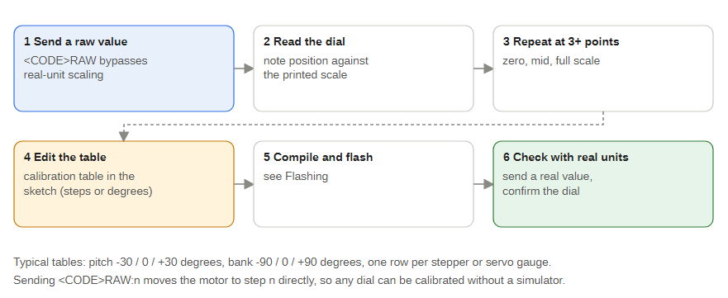
Figure 24 — The calibration loop

11.1 Calibrating a servo
- Send raw positions with BANKRAW or PITCHRAW (for example D,PITCHRAW:113) until the instrument shows a known attitude.
- Note the position for each attitude you check: at least both ends and level.
- Enter them in PITCH_DEG_TABLE or BANK_DEG_TABLE, and set aServZeroPosition[] to the level position so the self-test parks there.
- Upload, then check with real values, for example D,PITCH:0 and D,BANK:30.

11.2 Calibrating a stepper gauge
- Send raw steps with the RAW token (for example D,TQRAW:300) and read the dial.
- Repeat at zero, mid scale and full scale (more points where the scale is not linear).
- Edit the gauge's table in the sketch (TQ_PCT_TABLE, IAS_KT_TABLE and so on) and its ...ZeroOffset trim if the zero is off.
- Upload and check with real values (D,TQ:60).
The StepperVSITester sends every token and raw token without a simulator. Do not drive a gauge hard against its mechanical stop: a stalled servo or stepper draws high current and gets hot.

12 Troubleshooting
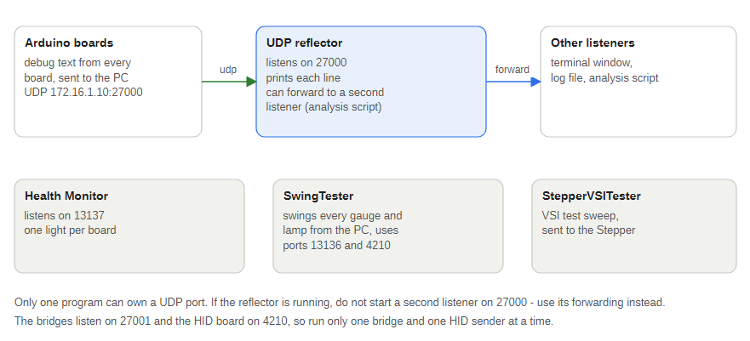
Figure 25 — Debug and test tools
Symptom | Likely cause | What to check
Red LED keeps fast-flashing, no gauge sweep | Board stuck in Ethernet start-up | Ethernet module seated; reset line on pin 53; module powered
Sweep runs but gauges never move in flight | Packets not reaching UDP 13136 | PC on 172.16.1.x; Windows firewall allows outbound UDP; the bridge sends to the right boards (servo .102, steppers .105 and .106); only one bridge running
No debug messages, or the Health Monitor shows a board as down | Listener or Health Monitor not running, or PC address wrong | PC at 172.16.1.10; listener bound to UDP 27000, Health Monitor to UDP 13137; firewall allows inbound UDP on both
One gauge pinned at an end stop | Value outside the calibration table, or table points wrong | Send the RAW token to find the true limits, then re-measure the table (see Calibration)
All gauges drop to zero after 30 seconds | No packets arriving (watchdog) | Bridge running and connected; simulator not paused; network link
Attitude indicator lags fast changes | 1 degree per 5 ms step limit | Expected; reduce servoCheckInterval to speed up
Servo buzzes or jitters | Weak servo supply | Separate 5 to 6 V supply for servos, common ground with the Mega
A lamp never lights | Wiring or the lamp's driver | It should light at the power-up lamp test; if not, check the A pin and its driver
A radio knob tunes the wrong radio | Bare frequency sent instead of a labelled one | Use the real board (it labels COM2, NAV1 and NAV2); the Radio emulator sends bare numbers, so only COM1 tunes
COM and NAV displays blank | Avionics bus below 24 V, or no data and no knob use for 30 seconds | Switch avionics on; turn a knob to wake them
Dual stepper OLEDs blank | Main bus below 24 V (PWR:0) | Switch the battery on; check the main bus voltage in the bridge window
Radio swap switches do nothing | Column 0 of the matrix stuck | Send C,MATRIX:1 and read the debug listener (see Radio controller)
FSUIPC binding fires the wrong event | EVT re-indexed after an update | Re-map the binding in FSUIPC
Joystick buttons vanish after a reset | USB HID board rebooted | Windows re-detects them within seconds; re-check games that had them open
Upload fails with Access is denied | Another program holds the COM port | Close the serial monitor and the Arduino IDE port; check the port with arduino-cli board list
Upload goes to the wrong board | COM port moved | Re-check Device Manager; see COM ports and flashing
Data reaches the boards only in bursts, with gaps of several seconds | The PC's Ethernet link to the board switch is dropping in and out | In Windows, check the network adapter stays connected; check the 5 V supply of the network switch stays above 4.75 V (it once dipped below and the switch dropped its ports), then the cable and switch port

12.1 Known issues in the code
Servo firmware (JET_RANGER_SERVO_CONTROLLER.ino)
- Brightness packets (C,B:n) are accepted but do nothing: no pin is assigned. The PCB has BACKLIGHT_PWM on pin 5 ready for it.
- powerAvailable is set from NAVCOM1 but nothing uses it, so the attitude indicator stays live when the simulator's power is off (the bridge sends all lamps off below 20 V).
- Several lamps log Transmission Temperature changed to the debug listener, whichever lamp changed.
- The PCB labels 10 of the 15 lamp outputs on different pins from the sketch (A1/A2, A5/A6, A7 to A10, A11/A12). Test each lamp on its own, for example D,RLOW:1, and correct whichever side is wrong.
FSUIPC event file (DODSIM206V2.EVT)
- The line before event 133 is missing its //, so FSUIPC may reject or mis-read it.
- Events 189 and 190 are named the wrong way round: 189 is called _SET but toggles, 190 is called _TOGGLE but takes 1 or 2.
- Events 69 to 71 mix up the instrument and cockpit light breakers: 69 is named COCKPIT_LT_CB_TOGGLE, and INST_LT_CB_SET appears twice.

12.2 Open questions
- Power supply rating for the servo rail and the 12 V lamp supply.
- Whether the estimates for the FlyInside and CowaSim aircraft hold at other power settings.

13 Reference: UDP tokens
From the current sketches. Gauge tokens take real units; lamp tokens take 0 (off) or 1 (on). UDP_Interface_Values.xlsx still lists the old 16-servo pin plan, so use these tables instead.

13.1 Gauge tokens
Token | Gauge | Board | Units
BANK | Attitude bank | Servo (.102) | degrees, plus and minus 90
PITCH | Attitude pitch | Servo (.102) | degrees, plus and minus 30
IAS | Airspeed | Stepper (.105) | knots, one decimal allowed
VSI | Vertical speed | Stepper (.105) | ft/min
AGL | Radar altitude | Stepper (.105) | feet
TQ | Engine torque | Stepper (.105) | %
N1 | Gas producer | Stepper (.105) | %
ITT | Turbine out temperature | Stepper (.105) or Dual (.106) | degrees C
FUEL | Fuel quantity | Stepper (.105) or Dual (.106) | US gal
OILT | Engine oil temperature | Dual (.106) or Stepper | degrees C
OILP | Engine oil pressure | Dual (.106) or Stepper | psi
XMSNT | Transmission oil temperature | Dual (.106) or Stepper | degrees C
XMSNP | Transmission oil pressure | Dual (.106) or Stepper | psi
RPME | Engine RPM (N2) | Dual (.106) | %, one decimal
RPMR | Rotor RPM | Dual (.106) | %, one decimal
ALT | Altimeter | Dual (.106), OLED (.104) | feet
FUELLOAD | Fuel load | Dual (.106) | psi
ELECTRICALLOAD | Electrical load | Dual (.106) | %
BARO | Barometric setting | OLED (.104) | inHg x 100
Every gauge token also has a RAW twin (for example PITCHRAW, IASRAW) that takes a raw servo position or stepper step count and skips the calibration table.

13.2 Lamp tokens (servo board)
Token | Lamp | Pin
EOUT | Engine out | A1
RLOW | Rotor RPM low | A2
TOPW | Transmission oil pressure | A3
TOTW | Transmission oil temperature | A4
BHOT | Battery hot | A5
BTMP | Battery temperature | A6
EC | Engine chip | A7
TRC | Tail rotor chip | A8
TC | Transmission chip | A9
BD | Baggage door | A10
FFLTR | Aft fuel filter | A11
FPMP | Fuel pump | A12
GENF | Generator fail | A13
LOWF | Low fuel | A14
SCF | SC fail (standby compass) | A15

13.3 Status and control tokens
Token | Packet | Meaning
NAVCOM1 | D | 0 = avionics bus below 24 V (radio COM and NAV displays blank), 1 = on
PWR | D | Dual stepper board: 1 = all four OLEDs on, 0 = blank them (main bus below 24 V). Sent first in the packet
ZULU | D | Zulu time as HHMM, for example 1430 (dual stepper clock OLED)
TEMP | D | Temperature text for the dual stepper's temperature OLED, for example 25C
B | C | Panel brightness 0 to 15 (not yet active)
SWING<CODE> | C | Runs one gauge's start-up sweep on demand, for example C,SWINGTQ:1 (stepper boards) or C,SWINGPITCH:1 (servo board); the value is ignored
OLEDTEST | C | 1 fills the four OLEDs solid white, 0 restores them (dual stepper board)
KEEPALIVE | C | Ignored command that still counts as received data and restarts the 30 second no-data timer (SwingTester sends it during a run)
RESET | C | Reboots the board about 2 seconds later (servo, stepper, dual stepper, radio and upper controllers on port 13136; USB HID board on port 4210). The radio and upper controllers use a software reset because a watchdog reset hung the radio's bootloader; the upper controller's reset has not been bench-tested
MATRIX | C | Radio controller: print the raw button matrix to the debug listener

